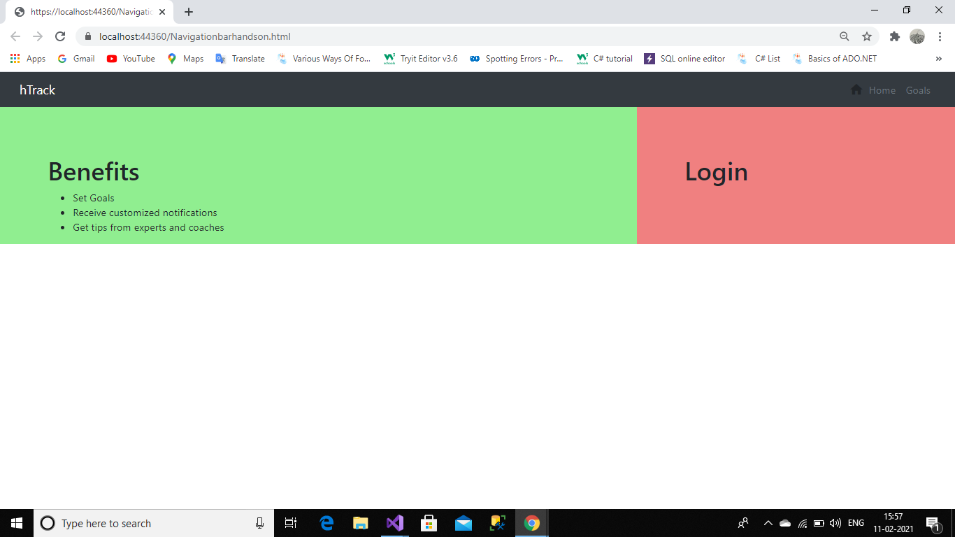

<!DOCTYPE html>

<html>

<head>

<meta charset="utf-8" />

<meta name="viewport" content="width=device-width, initial-scale=1">

<title></title>

<link href="Content/bootstrap.min.css" rel="stylesheet" />

<link href="https://fonts.googleapis.com/icon?family=Material+Icons" rel="stylesheet"/>

</head>

<body>

<div class="container-fluid bg-dark ">

<nav class="navbar navbar-expand-sm justify-content-between">

<div>

<span class="navbar-brand text-white">hTrack</span>

</div>

<div>

<ul class="navbar-nav">

<li><i class="material-icons mt-2">home</i></li>

<li class="nav-item"><a class="nav-link disabled" href="#">Home</a></li>

<li class="nav-item"><a class="nav-link disabled" href="#">Goals</a></li>

</ul>

</div>

</nav>

</div>

<div class="container-fluid">

<div class="row" style="height:auto">

<div class="col-md-8" style="background-color: lightgreen;padding-left: 5%;padding-top: 5%">

<h1>Benefits</h1>

<ul>

<li>Set Goals</li>

<li>Receive customized notifications</li>

<li>Get tips from experts and coaches</li>

</ul>

</div>

<div class="col-md-4" style="background-color:lightcoral;padding-left:5%;padding-top:5%">

<h1>Login</h1>

</div>

</div>

</div>

<script src="Scripts/jquery-3.0.0.slim.min.js"></script>

<script src="Scripts/umd/popper.min.js"></script>

<script src="Scripts/bootstrap.min.js"></script>

</body>

</html>

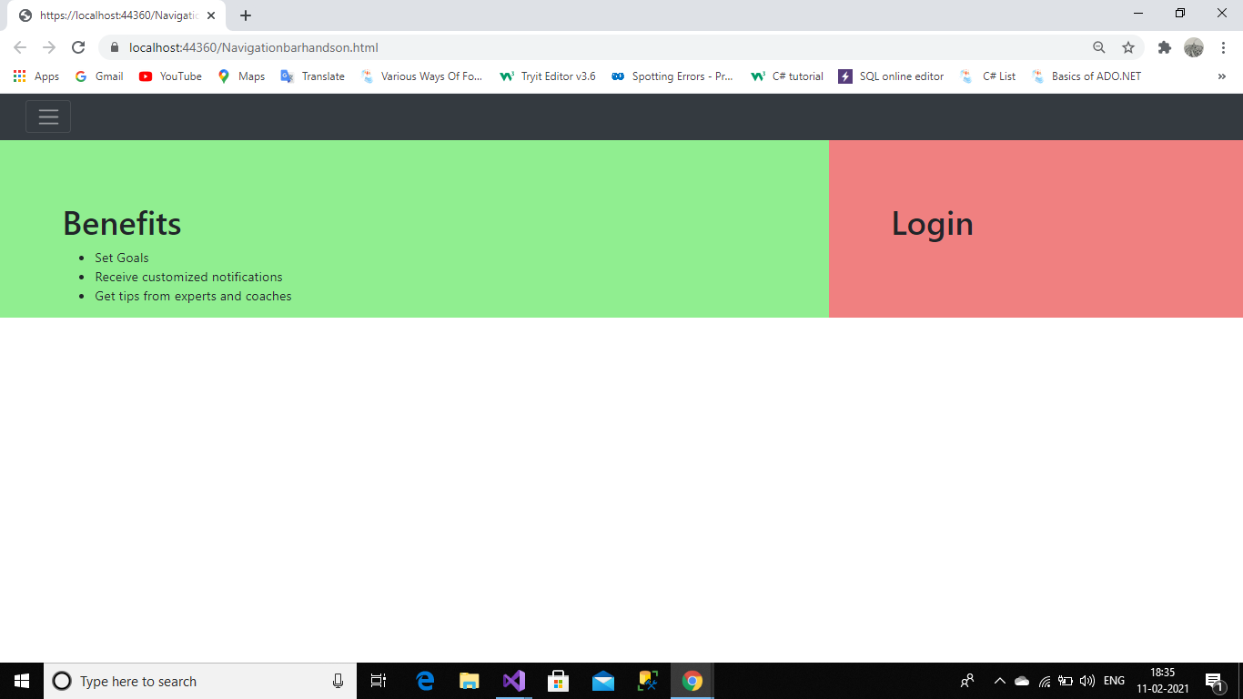

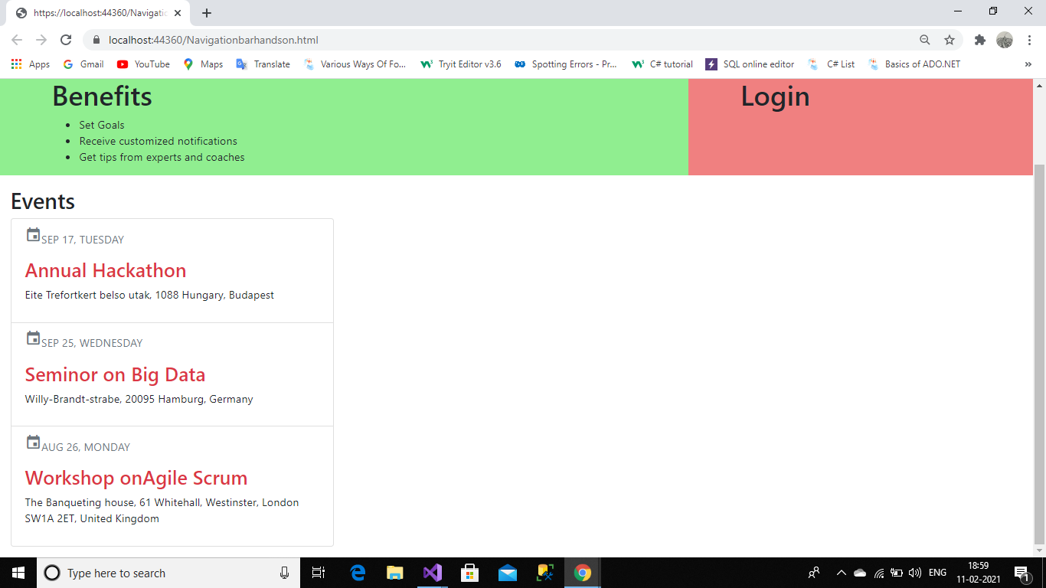

<!DOCTYPE html>

<html>

<head>

<meta charset="utf-8" />

<meta name="viewport" content="width=device-width, initial-scale=1">

<title></title>

<link href="Content/bootstrap.min.css" rel="stylesheet" />

<link href="https://fonts.googleapis.com/icon?family=Material+Icons" rel="stylesheet"/>

</head>

<body>

<div class="container-fluid bg-dark ">

<nav class="navbar navbar-expand-sm justify-content-between">

<div>

<span class="navbar-brand text-white">hTrack</span>

</div>

<div>

<nav class=”navbar navbar-inverse navbar-static-top”>

<ul class="navbar-nav">

<li><i class="material-icons mt-2">home</i></li>

<li class="nav-item"><a class="nav-link disabled" href="#">Home</a></li>

<li class="nav-item"><a class="nav-link disabled" href="#">Goals</a></li>

</ul>

</nav>

</div>

</nav>

</div>

<!--<div class="pos-f-t">

<div class="collapse" id="navbarToggleExternalContent">

<div class="bg-dark p-4">

<h5 class="text-white h4">Collapsed content</h5>

<span class="text-muted">Toggleable via the navbar brand.</span>

</div>

</div>

<nav class="navbar navbar-dark bg-dark">

<div class="container-fluid">

<button class="navbar-toggler" type="button" data-bs-toggle="collapse" data-bs-target="#navbarToggleExternalContent" aria-controls="navbarToggleExternalContent" aria-expanded="false" aria-label="Toggle navigation">

<span class="navbar-toggler-icon"></span>

</button>

</div>

</nav>

</div>-->

<div class="container-fluid">

<div class="row" style="height:auto">

<div class="col-md-8" style="background-color: lightgreen;padding-left: 5%;padding-top: 5%">

<h1>Benefits</h1>

<ul>

<li>Set Goals</li>

<li>Receive customized notifications</li>

<li>Get tips from experts and coaches</li>

</ul>

</div>

<div class="col-md-4" style="background-color:lightcoral;padding-left:5%;padding-top:5%">

<h1>Login</h1>

</div>

</div>

</div>

<div class="mt-3 mb-3 col-4">

<h2>Events</h2>

<div class="list-group">

<div class="list-group-item">

<p class="text-secondary"><i class="material-icons">event</i>SEP 17, TUESDAY</p>

<h3 class="text-danger">Annual Hackathon</h3>

<p>Eite Trefortkert belso utak, 1088 Hungary, Budapest</p>

</div>

<div class="list-group-item">

<p class="text-secondary"><i class="material-icons">event</i>SEP 25, WEDNESDAY</p>

<h3 class="text-danger">Seminor on Big Data</h3>

<p>Willy-Brandt-strabe, 20095 Hamburg, Germany</p>

</div>

<div class="list-group-item">

<p class="text-secondary"><i class="material-icons">event</i>AUG 26, MONDAY</p>

<h3 class="text-danger">Workshop onAgile Scrum</h3>

<p>The Banqueting house, 61 Whitehall, Westinster, London SW1A 2ET, United Kingdom</p>

</div>

</div>

</div>

<script src="Scripts/jquery-3.0.0.slim.min.js"></script>

<script src="Scripts/umd/popper.min.js"></script>

<script src="Scripts/bootstrap.min.js"></script>

</body>

</html>